Project 11_ FIFA World Cup Analysis

**1. Number of World Cups Hosted by Each Country (Bar Chart)**

**Summary:** This bar chart displays the number of World Cups hosted by each country. Each bar represents a country, and the height of the bar indicates the number of times that country has hosted the World Cup.

* Brazil has hosted the World Cup the greatest number of times, followed by Italy and Germany.
* Some countries have never hosted the World Cup.

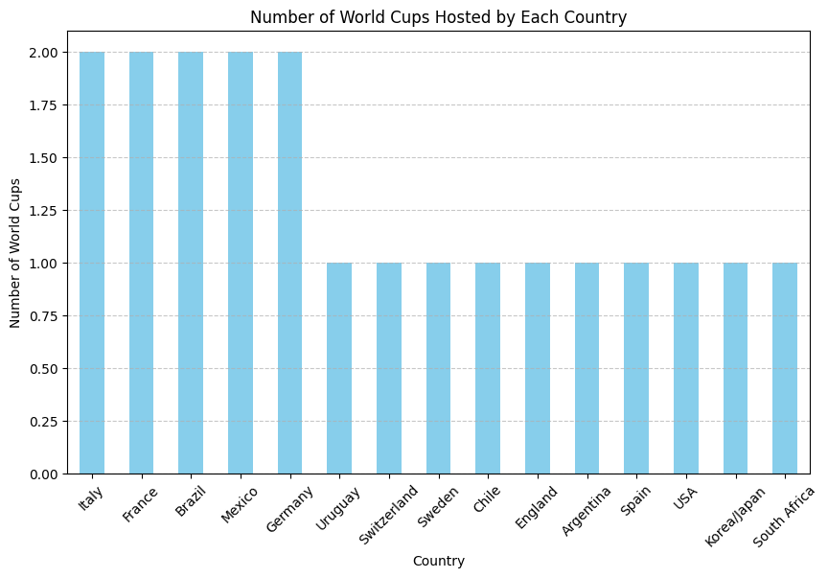

**2. Average Attendance per World Cup for Each Year (Line Chart)**

**Summary:** The line chart shows the average attendance per World Cup for each year. Each point on the line represents a specific World Cup year, and the vertical position of the point indicates the average attendance for that year.

* Average attendance tends to fluctuate over the years, with some peaks and dips.
* There is a general trend of increasing average attendance over time, indicating growing interest in the World Cup.

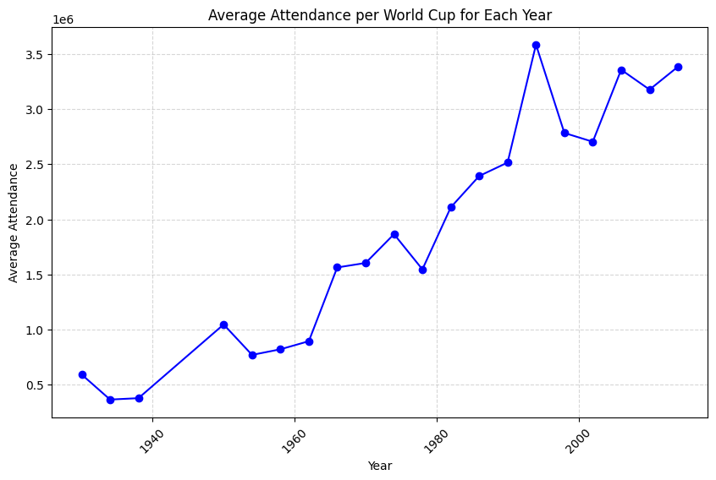

**3. Top 5 Countries with the Most World Cup Wins (Horizontal Bar Chart)**

**Summary:** This horizontal bar chart displays the top 5 countries with the most World Cup wins. Each bar represents a country, and the length of the bar indicates the number of times that country has won the World Cup.

* Brazil has won the most number of World Cups, followed by Italy, Germany, Argentina, and Uruguay.
* These top 5 countries have historically dominated the World Cup tournament.

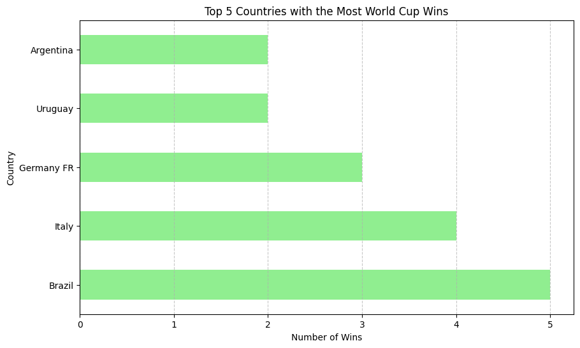

**4. Distribution of Home and Away Team Goals (Histogram)**

**Summary:** The histogram shows the distribution of goals scored by home and away teams in World Cup matches.

* The x-axis represents the number of goals scored, and the y-axis represents the frequency of matches.
* Both home and away team goals follow a similar distribution, with most matches having a low number of goals scored by either team.

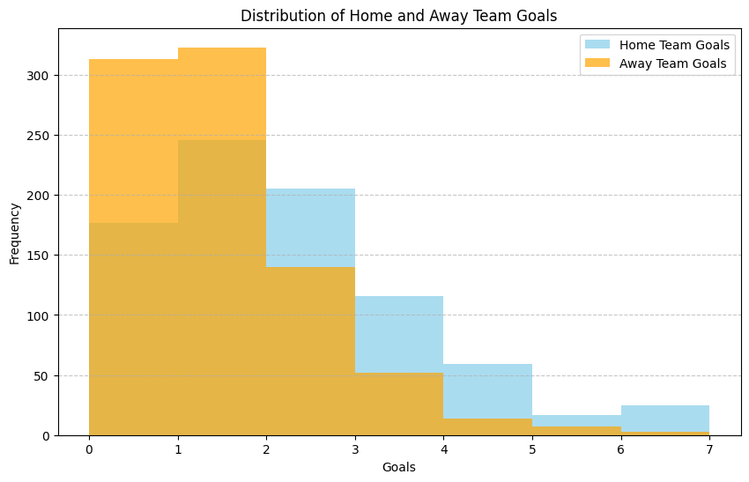

**5. Match Outcome Distribution (Pie Chart)**

**Summary:** This pie chart displays the distribution of match outcomes in World Cup matches. It categorizes matches into three outcomes: Home Win, Away Win, and Draw.

* Home Win: Represents the percentage of matches where the home team scored more goals than the away team.
* Away Win: Represents the percentage of matches where the away team scored more goals than the home team.
* Draw: Represents the percentage of matches where the number of goals scored by both teams was equal.

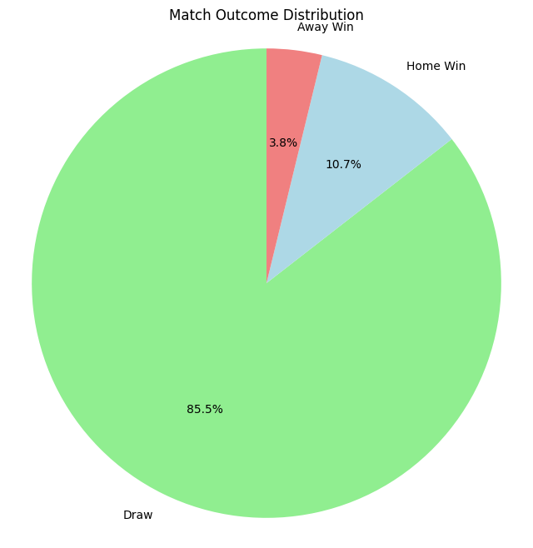

**6. Average Attendance per Match for Each Year (Line Chart)**

**Summary:** The line chart shows the average attendance per match for each year of the World Cup tournament.

* Each point on the line represents a specific year, and the vertical position of the point indicates the average attendance per match for that year.
* There is a general trend of increasing average attendance per match over the years, suggesting growing interest and larger crowds attending World Cup matches.

